# WT-SFP+ DWDM

**10Gb/s DWDM 80KM SFP+ Transceiver**

## PRODUCT FEATURES

* Hot-pluggable SFP+ footprint 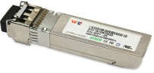
* Supports 9.5 to 10.3Gb/s bit rates
* Power dissipation < 1.5W
* Single 3.3V power supply
* Maximum link length of 80km
* DWDM wavelength EML transmitter, APD photo-detector
* Duplex LC connector
* Power dissipation < 1.5W
* Built-in digital diagnostic functions
* Case temperature range ：-5°C to 70°C

**APPLICATIONS**

* 10GBASE-ZR/ZW 10G Ethernet

**STANDARD**

* Compliant with SFF-8472 SFP+ MSA.
* Compliant to SFP+ SFF-8431 and SFF-8432.
* Compliant to 802.3ae 10GBASE-ZR.
* RoHS Compliant.

**PRODUCT DESCRIPTION**

WT-SFP+DWDM-XX-ZR is designed for use in 10-Gigabit Ethernet links up to 80km over single mode fiber. The module consists of DWDM EML Laser, APD and Preamplifier in a high-integrated optical sub-assembly. Digital diagnostics functions are available via a 2-wire serial interface, as specified in SFF8472. The module data link up to 80km in 9/125um single mode fiber.

|  |  |  |  |
| --- | --- | --- | --- |
| **Channel #** | **Part Number** | **Frequency (THz)** | **Center Wave (nm)** |
| 21 | WT-SFP+-DWDM-ER/ZR-21 | 192.1 | 1560.61 |
| 22 | WT-SFP+-DWDM-ER/ZR-22 | 192.2 | 1559.79 |
| 23 | WT-SFP+-DWDM-ER/ZR-23 | 192.3 | 1558.98 |
| 24 | WT-SFP+-DWDM-ER/ZR-24 | 192.4 | 1558.17 |
| 25 | WT-SFP+-DWDM-ER/ZR-25 | 192.5 | 1557.36 |
| 26 | WT-SFP+-DWDM-ER/ZR-26 | 192.6 | 1556.55 |
| 27 | WT-SFP+-DWDM-ER/ZR-27 | 192.7 | 1555.75 |
| 28 | WT-SFP+-DWDM-ER/ZR-28 | 192.8 | 1554.94 |
| 29 | WT-SFP+-DWDM-ER/ZR-29 | 192.9 | 1554.13 |
| 30 | WT-SFP+-DWDM-ER/ZR-30 | 193.0 | 1553.33 |
| 31 | WT-SFP+-DWDM-ER/ZR-31 | 193.1 | 1552.52 |
| 32 | WT-SFP+-DWDM-ER/ZR-32 | 193.2 | 1551.72 |
| 33 | WT-SFP+-DWDM-ER/ZR-33 | 193.3 | 1550.92 |
| 34 | WT-SFP+-DWDM-ER/ZR-34 | 193.4 | 1550.12 |
| 35 | WT-SFP+-DWDM-ER/ZR-35 | 193.5 | 1549.32 |
| 36 | WT-SFP+-DWDM-ER/ZR-36 | 193.6 | 1548.51 |
| 37 | WT-SFP+-DWDM-ER/ZR-37 | 193.7 | 1547.72 |
| 38 | WT-SFP+-DWDM-ER/ZR-38 | 193.8 | 1546.92 |
| 39 | WT-SFP+-DWDM-ER/ZR-39 | 193.9 | 1546.12 |
| 40 | WT-SFP+-DWDM-ER/ZR-40 | 194.0 | 1545.32 |
| 41 | WT-SFP+-DWDM-ER/ZR-41 | 194.1 | 1544.53 |
| 42 | WT-SFP+-DWDM-ER/ZR-42 | 194.2 | 1543.73 |
| 43 | WT-SFP+-DWDM-ER/ZR-43 | 194.3 | 1542.94 |
| 44 | WT-SFP+-DWDM-ER/ZR-44 | 194.4 | 1542.14 |
| 45 | WT-SFP+-DWDM-ER/ZR-45 | 194.5 | 1541.35 |
| 46 | WT-SFP+-DWDM-ER/ZR-46 | 194.6 | 1540.56 |
| 47 | WT-SFP+-DWDM-ER/ZR-47 | 194.7 | 1539.77 |
| 48 | WT-SFP+-DWDM-ER/ZR-48 | 194.8 | 1538.98 |
| 49 | WT-SFP+-DWDM-ER/ZR-49 | 194.9 | 1538.19 |
| 50 | WT-SFP+-DWDM-ER/ZR-50 | 195.0 | 1537.40 |
| 51 | WT-SFP+-DWDM-ER/ZR-51 | 195.1 | 1536.61 |
| 52 | WT-SFP+-DWDM-ER/ZR-52 | 195.2 | 1535.82 |
| 53 | WT-SFP+-DWDM-ER/ZR-53 | 195.3 | 1535.04 |
| 54 | WT-SFP+-DWDM-ER/ZR-54 | 195.4 | 1534.25 |
| 55 | WT-SFP+-DWDM-ER/ZR-55 | 195.5 | 1533.47 |
| 56 | WT-SFP+-DWDM-ER/ZR-56 | 195.6 | 1532.68 |

|  |  |  |  |
| --- | --- | --- | --- |
| 57 | WT-SFP+-DWDM-ER/ZR-57 | 195.7 | 1531.90 |
| 58 | WT-SFP+-DWDM-ER/ZR-58 | 195.8 | 1531.12 |
| 59 | WT-SFP+-DWDM-ER/ZR-59 | 195.9 | 1530.33 |

1. **Absolute Maximum Ratings**

|  |  |  |  |  |  |  |
| --- | --- | --- | --- | --- | --- | --- |
| **Parameter** | **Symbol** | **Min.** | **Typ.** | **Max.** | **Unit** | **Note** |
| Storage Temperature | Ts | -40 |  | 85 | ºC |  |
| Storage Ambient Humidity | HA | 5 |  | 85 | % |  |
| Power Supply Voltage | VCC | -0.5 |  | 4 | V |  |
| Signal Input Voltage |  | -0.3 |  | Vcc+0.3 | V |  |
| Receiver Damage Threshold |  | +4 |  |  | dBm |  |

1. **Recommended Operating Conditions**

|  |  |  |  |  |  |  |
| --- | --- | --- | --- | --- | --- | --- |
| **Parameter** | **Symbol** | **Min.** | **Typ.** | **Max.** | **Unit** | **Note** |
| Operating Case Temperature | Tcase | -5 |  | 70 | ºC | Note (1) |
| Ambient Humidity | HA | 5 |  | 85 | % |  |
| Power Supply Voltage | VCC | 3.14 | 3.3 | 3.46 | V |  |
| Power Supply Current | ICC |  |  | 450 | mA |  |
| Power Supply Noise  Rejection |  |  |  | 100 | mVp-p | 100Hz to 1MHz |
| Transmission Distance |  |  |  | 70 | km |  |
| Coupled fiber | Single mode fiber | | | | | ITU-T G.653 |

Note: -10 to 60degC with 1.5m/s airflow

## Optical Characteristics

|  |  |  |  |  |  |  |
| --- | --- | --- | --- | --- | --- | --- |
| **Parameter** | **Symbol** | **Min.** | **Typ.** | **Max.** | **Unit** | **Note** |
| **Transmitter** | | | | | | |
| Average Launched Power | PO | 0 |  | +5 | dBm | Note (1) |
| Extinction Ratio | ER | 6 |  |  | dB |  |
| Center Wavelength—End of Life | λc | X-100 | X | X+100 | pm |  |
| Center Wavelength—Beginning of Life | λc | X-25 | X | X+25 | pm |  |
| Center Wavelength Space |  |  | 100 |  | GHz |  |
| Spectrum Band Width (RMS) | σ |  |  | 1.0 | nm |  |
| SMSR |  | 30 |  |  | dB |  |
| Transmitter OFF Output Power | POff |  |  | -40 | dBm |  |
| TX Jitter (peak-peak) | Txj |  |  | 0.1 | UI |  |
| TX Jitter (RMS) | Txjrms |  |  | 0.01 | UI |  |
| Transmitter and Dispersion Penalty | TDP |  |  | 3.0 | dB |  |
| Output Eye Mask | Compliant with IEEE 0802.3ae | | | |  |  |
| **Receiver** | | | | | | |
| Input Optical Wavelength | λ | 1270 |  | 1610 | nm |  |
| Receiver Sensitivity |  |  |  | -23 | dBm | Note (2) |
| Input Saturation Power (Overload) | Psat | -8 |  |  | dBm |  |
| LOS Detect -Assert Power | PA | -32 |  |  | dBm |  |
| LOS Detect - Deassert Power | PD |  |  | -30 | dBm |  |
| LOS Detect Hysteresis | PHYS | 2 |  |  | dB |  |

Note：

1. Launched power (avg.) is power coupled into a single mode fiber with master connector.（Before of Life）
2. Measured with conformance test signal for BER = 10^–[12.@10.3125Gbps,](mailto:12.@10.3125Gbps) PRBS=2^31-1,NRZ

## Electrical Interface Characteristics

|  |  |  |  |  |  |  |
| --- | --- | --- | --- | --- | --- | --- |
| **Parameter** | **Symbol** | **Min.** | **Typ.** | **Max.** | **Unit** | **Note** |
| **Transmitter** | | | | | | |
| Differential line input Impedance | RIN |  | 100 |  | Ohm |  |
| Differential Data Input Swing | VDT | 300 |  | 700 | mVp-p |  |
| Transmit Disable Voltage | Vdis | 2 |  | Vcc | V | LVTTL |
| Transmit Enable Voltage | Ven | Vee |  | Vee+0.8 | V |
| **Receiver** | | | | | | |
| Differential Data Output Swing | VDR | 400 |  | 850 | mVp-p | Note (1) |
| LOS Output Voltage-High | VLOSH | Vee |  | Vee+0.8 | V | LVTTL |
| LOS Output Voltage-Low | VLOSL | 2 |  | VccHOST | V |

Note: Into 100Ω differential termination.

## Pin Description

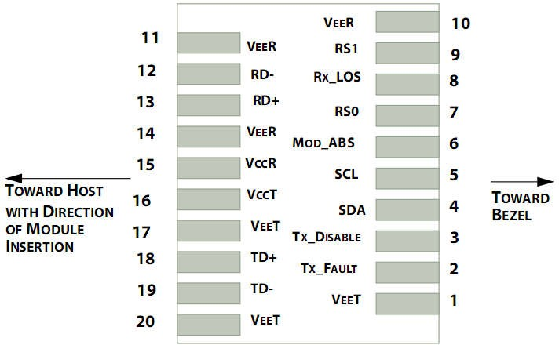

**Pin out of Connector Block on Host Board**

|  |  |  |  |
| --- | --- | --- | --- |
| **Pin** | **Symbol** | **Name/Description** | **Ref.** |
| 1 | V  EET | Transmitter Ground (Common with Receiver Ground) | 1 |
| 2 | T  FAULT | Transmitter Fault. | 2 |
| 3 | T  DIS | Transmitter Disable. Laser output disabled on high or open. | 3 |
| 4 | SDA | 2-wire Serial Interface Data Line | 4 |
| 5 | SCL | 2-wire Serial Interface Clock Line | 4 |
| 6 | MOD_ABS | Module Absent. Grounded within the module | 4 |
| 7 | RS0 | Rate Select 0 | 5 |
| 8 | LOS | Loss of Signal indication. Logic 0 indicates normal operation. | 6 |
| 9 | RS1 | No connection required | 1 |
| 10 | V  EER | Receiver Ground (Common with Transmitter Ground) | 1 |
| 11 | V  EER | Receiver Ground (Common with Transmitter Ground) | 1 |
| 12 | RD- | Receiver Inverted DATA out. AC Coupled |  |
| 13 | RD+ | Receiver Non-inverted DATA out. AC Coupled |  |
| 14 | V  EER | Receiver Ground (Common with Transmitter Ground) | 1 |
| 15 | V  CCR | Receiver Power Supply |  |
| 16 | V  CCT | Transmitter Power Supply |  |
| 17 | V  EET | Transmitter Ground (Common with Receiver Ground) | 1 |

|  |  |  |  |
| --- | --- | --- | --- |
| 18 | TD+ | Transmitter Non-Inverted DATA in. AC Coupled. |  |
| 19 | TD- | Transmitter Inverted DATA in. AC Coupled. |  |
| 20 | V  EET | Transmitter Ground (Common with Receiver Ground) | 1 |

**Notes:**

* 1. Circuit ground is internally isolated from chassis ground.
  2. TFAULT is an open collector/drain output, which should be pulled up with a 4.7k – 10k Ohms resistor on the host board if intended for use. Pull up voltage should be between 2.0V to Vcc + 0.3V.A high output indicates a transmitter fault caused by either the TX bias current or the TX output power exceeding the preset alarm thresholds. A low output indicates normal operation. In the low state, the output is pulled to

<0.8V.

* 1. Laser output disabled on TDIS >2.0V or open, enabled on TDIS <0.8V.
  2. Should be pulled up with 4.7kΩ- 10kΩ host board to a voltage between 2.0V and 3.6V. MOD_ABS pulls line low to indicate module is plugged in.
  3. Internally pulled down per SFF-8431 Rev 4.1.
  4. LOS is open collector output. It should be pulled up with 4.7kΩ – 10kΩ on host board to a voltage between 2.0V and 3.6V. Logic 0 indicates normal operation; logic 1 indicates loss of signal.

## Recommended Interface Circuit

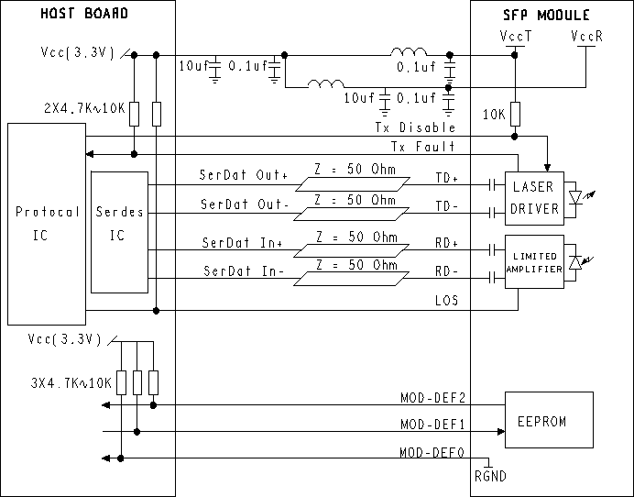

**VIII. Regulatory Compliance**

|  |  |  |
| --- | --- | --- |
| **Feature** | **Reference** | **Performance** |
| Electrostatic discharge（ESD） | IEC/EN 61000-4-2 | Compatible with standards |
| Electromagnetic Interference  (EMI) | FCC Part 15 Class B EN 55022  Class B (CISPR 22A) | Compatible with standards |
| Laser Eye Safety | FDA 21CFR 1040.10, 1040.11  IEC/EN 60825-1, 2 | Class 1 laser product |
| Component Recognition | IEC/EN 60950, UL | Compatible with standards |
| ROHS | 2002/95/EC | Compatible with standards |
| EMC | EN61000-3 | Compatible with standards |

1. **Outline Dimensions**

